1st April 2015

**YOKOHAMA to Exhibit at Aircraft Interiors Expo 2015**

Tokyo ‒ The Yokohama Rubber Co., Ltd., announced today that it will again participate in the annual Aircraft Interiors Expo to be held in Hamburg Messe in Germany over the three days of 14th ‒ 16th April. The YOKOHAMA booth will display the Company's line-up of aircraft lavatory products, including its retrofit module for use when upgrading current onboard facilities.

YOKOHAMA manufactures and sells a wide range of aircraft components, including water tanks, thermal insulation materials, lightweight composite materials, and honeycomb structures. YOKOHAMA’s lavatory modules based on its lightweight composite materials have won high acclaim from aircraft manufacturers. In addition to being original equipment in the Boeing 757, they have been used in the Boeing 737 family of aircraft since 2004. YOKOHAMA also develops custom-made replacement modules for airlines seeking to upgrade facilities on in-service aircraft. YOKOHAMA’s line-up of aircraft components also includes drinking water tanks and onboard stairways used in Boeing’s 747-8I.

The Aircraft Interiors Expo is a world-class trade show featuring aircraft interior products, as well as related materials and leading-edge technologies. The Expo is held each spring in Germany, with a sister show in the autumn in the United States. The Expo is an optimal venue for YOKOHAMA and other producers of aircraft interior components to introduce their products to aircraft manufacturers and airline companies.

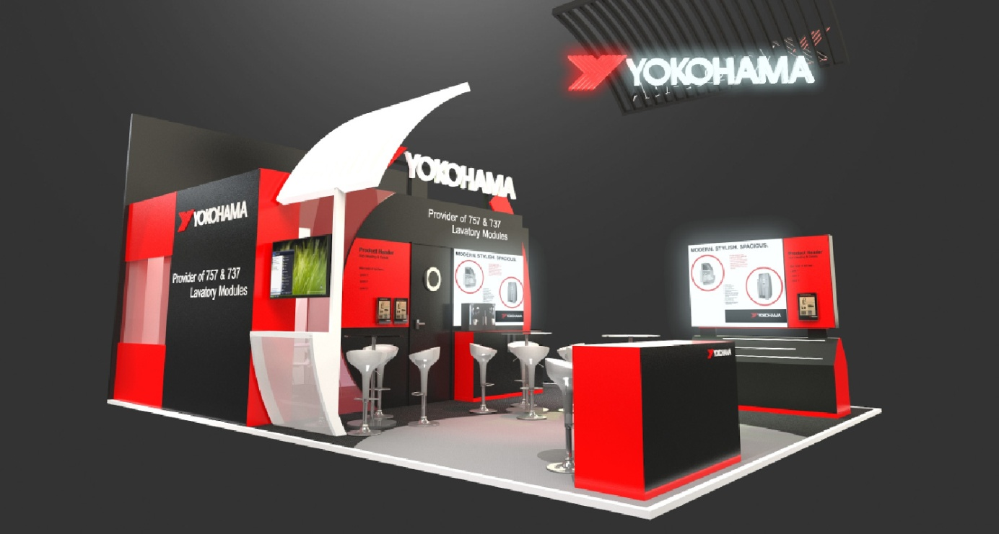Image of YOKOHAMA booth at Aircraft Interiors Expo